Times of Prayer
- Which prayer time begins when the sun moves west from the middle of the sky?

- Which prayer time begins when the shadow on an object becomes equal in length to it in addition to the length of its shadow when the sun was in the middle of the sky?
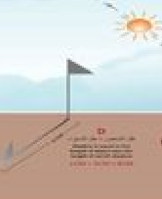

- Which prayer time begins after the sun sets?

- Which prayer time begins when the redness in the western horizon disappears?
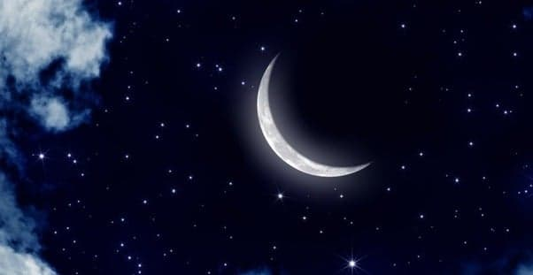

- Which prayer time begins when the true dawn appears?

